JOUR 4251
Psychology of Advertising 2.2 Attention, perception, processing
Recap Tuesday
Sales response models
○ Concave
○ S-shape
Behavioral approaches
● Hierarchy of effects models
○ AIDA
○ Foote, Cone, and Belding Grid
● Cognitive response approach
● Dual process theories
○ Effortful, slow, analytical processing ○ Fast, automatic, implicit processing ○ Ego-depletion
Preattentive analysis Focal attention Comprehension Elaborative reasoning
Stages of processing

1. Preattentive analysis
2. Focal Attention
3. Comprehension
4. Elaborative Reasoning
What determines that you go from one to the next stage?
Level of involvement.
Preattentive analysis Focal attention Comprehension Elaborative reasoning
Preattentive analysis Focal attention Comprehension Elaborative reasoning
1. Preattentive analysis
● Involuntarily exposed to advertising
○ Flipping through a magazine, watching TV, aren’t focused on it
● Stored in implicit memory
○ Nonconscious form
● Can have effects later on
○ You may later recall information about the product
Preattentive analysis Focal attention Comprehension Elaborative reasoning
1. Preattentive analysis
Feature Analysis
● Perceptual features, such as contours, shape, color etc.
Challenge?
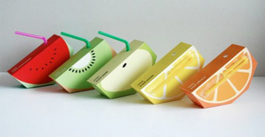
Preattentive analysis Focal attention Comprehension Elaborative reasoning

1. Preattentive analysis
Feature Analysis
● Perceptual features, such as contours, shape, color etc.
Challenge?
Semantic Analysis
● Meaning of product: You may remember what the product does, without realizing you learned it
● You remember more when you see the product used in a familiar scene rather than in isolation
Consequence?
Preattentive analysis Focal attention Comprehension Elaborative reasoning
Preattentive analysis Focal attention Comprehension Elaborative reasoning
Preattentive analysis Focal attention Comprehension Elaborative reasoning
Hedonic fluency
1. Subjective ease with which a stimulus can be perceived and processed 2. Mildly positive emotion
Perceptual fluency
Ease with which physical features can be perceived (e.g., how bright it is)
Conceptual fluency
Ease with which conceptual meaning can be understood
Familiarity (seen it before)
Example: More repetitive songs get higher on Billboard
Preattentive analysis Focal attention Comprehension Elaborative reasoning
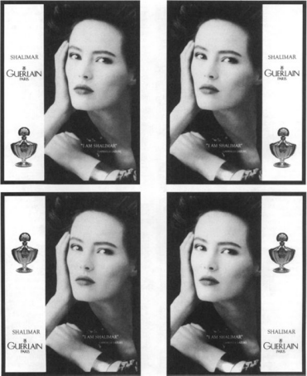
Which looks better?
Where to place
the brand name?
Preattentive analysis Focal attention Comprehension Elaborative reasoning
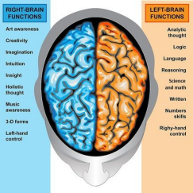
Matching activation
Left vs. right hemisphere of the brain
Right hemisphere
● Holistic, impressionistic processing
● Pictures
Left hemisphere
● Data-driven feature analysis
● Text
Note: simple words (e.g., brand name) can be
processed with equal efficiency by either hemisphere
Preattentive analysis Focal attention Comprehension Elaborative reasoning
Matching activation hypothesis
Assumes that when one brain hemisphere is processing information, the other is activated and can process nonfocal information.
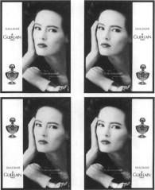
● If the name is next to the face, it needs to be on
the RIGHT, and if it is next to the slogan, it needs
to be on the LEFT
● They did subsequent studies to show this is the
fact, not balance or other explanations
Preattentive analysis Focal attention Comprehension Elaborative reasoning
Stages of processing
1. Preattentive analysis
2. Focal Attention
3. Comprehension
4. Elaborative Reasoning
Preattentive analysis Focal attention Comprehension Elaborative reasoning
2. Focal Attention
Previously, we weren’t talking about conscious awareness. Now we are.
How we bring an advertisement into short-term (working) memory - Consciously paying attention to it
WHAT HAPPENS?
WHY do you think you notice an ad and remember it?
Preattentive analysis Focal attention Comprehension Elaborative reasoning
What determines what we pay attention? 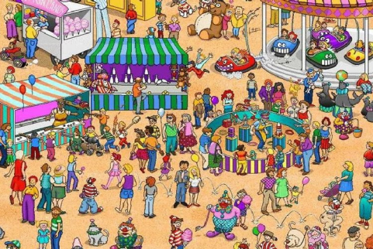
1. Motivations
2. Salience
3. Vividness
4. Novelty
Preattentive analysis Focal attention Comprehension Elaborative reasoningMotivations
Preattentive analysis Focal attention Comprehension Elaborative reasoning
Salience
Extent to which it is noticeably different from its environment; context dependent.
● Breaks through the advertising clutter
● One technique: upward angle of the camera - makes brand bigger (figure-ground principle) ● Matters more if you are NOT motivated to process the message. If you are, then it has less of an effect

Preattentive analysis Focal attention Comprehension Elaborative reasoning
Vividness
Salience is a function of context; vividness is not fully context dependent
● Emotionally interesting
● Concrete, image-provoking
● Proximate in a temporally or spatial way
Can be in stimuli OR the recipient
More effective in persuasion in people who are high on vividness questionnaire (i.e., visual people)
What is vivid to recipient depends on his/her goals.
Preattentive analysis Focal attention Comprehension Elaborative reasoning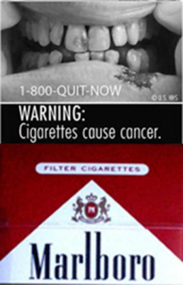
Preattentive analysis Focal attention Comprehension Elaborative reasoning
Novelty
The perception of “newness”: Whether the information is unfamiliar or does not conform to expectations
Makes us THINK more - extended processing
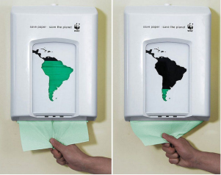
Repetition-variation hypothesis:
Varying the advertising strategy to maintain novelty
What’s next?
● Read chapter 2
○ Submit reading response by Thursday Feb 6, 2:30 pm
● Read description of assignment 2 on attention by next class ○ Explain in class on Tuesday / opportunity to ask questions ○ Deadline: Thursday, February 13 before class starts